DESKTOP-BASED TECHNICAL DEBT MANAGEMENT SOFTWARE

This project is a desktop-based Technical Debt Management Software designed to help organizations identify, track, analyze, and reduce technical debt during software evolution. It allows users to manage projects, record debt items, calculate debt scores, create refactoring tasks, track software versions, analyze debt trends, and generate reports. The system uses a database to maintain project information and provides a user-friendly dashboard for monitoring overall software health and supporting better maintenance and refactoring decisions.
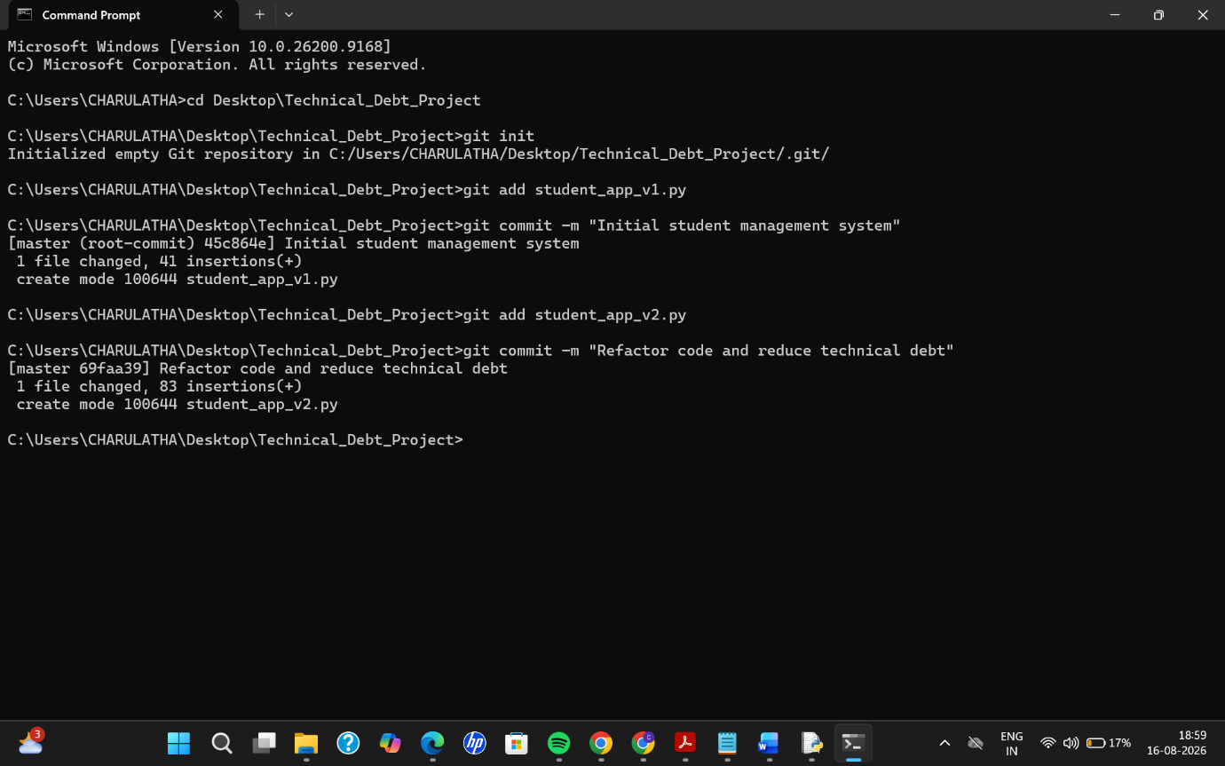
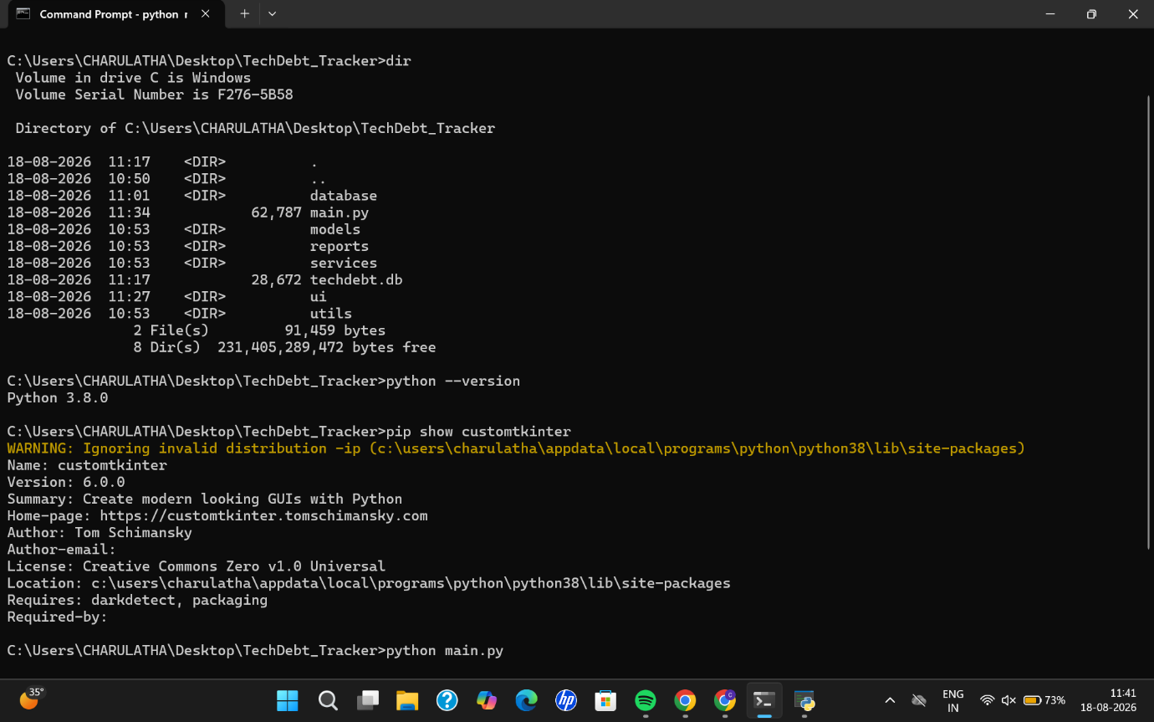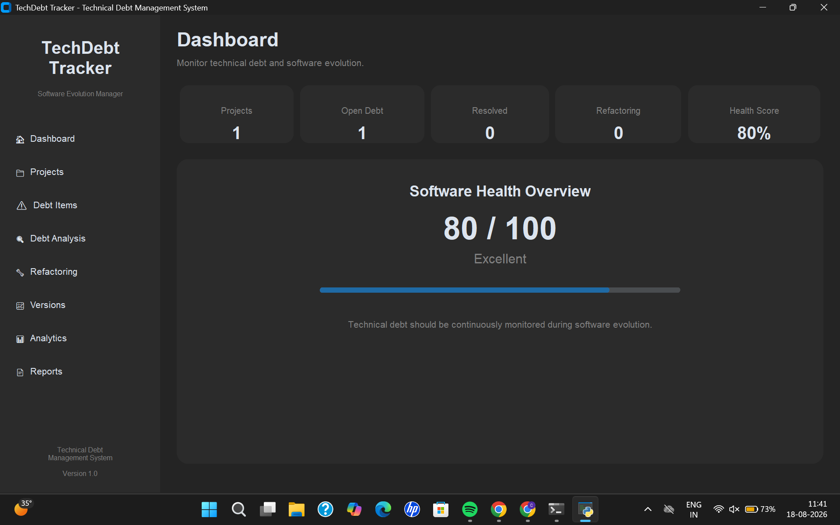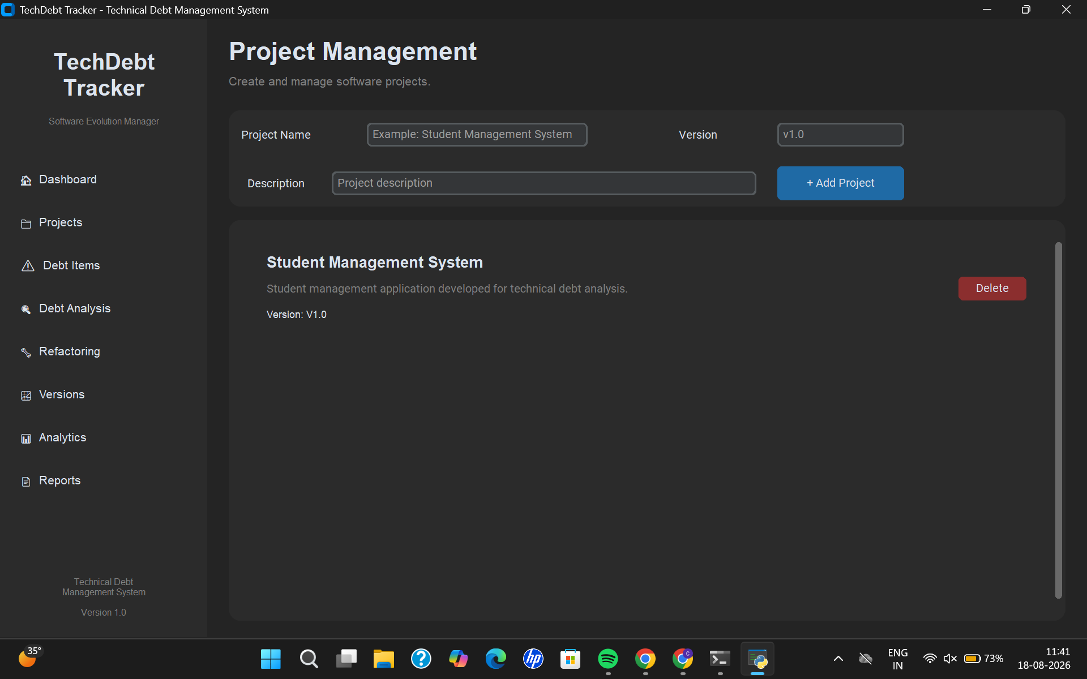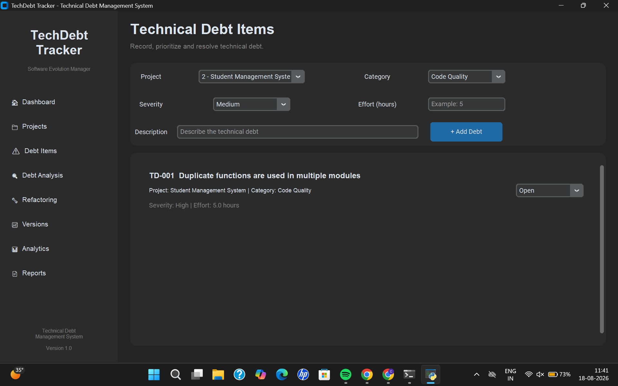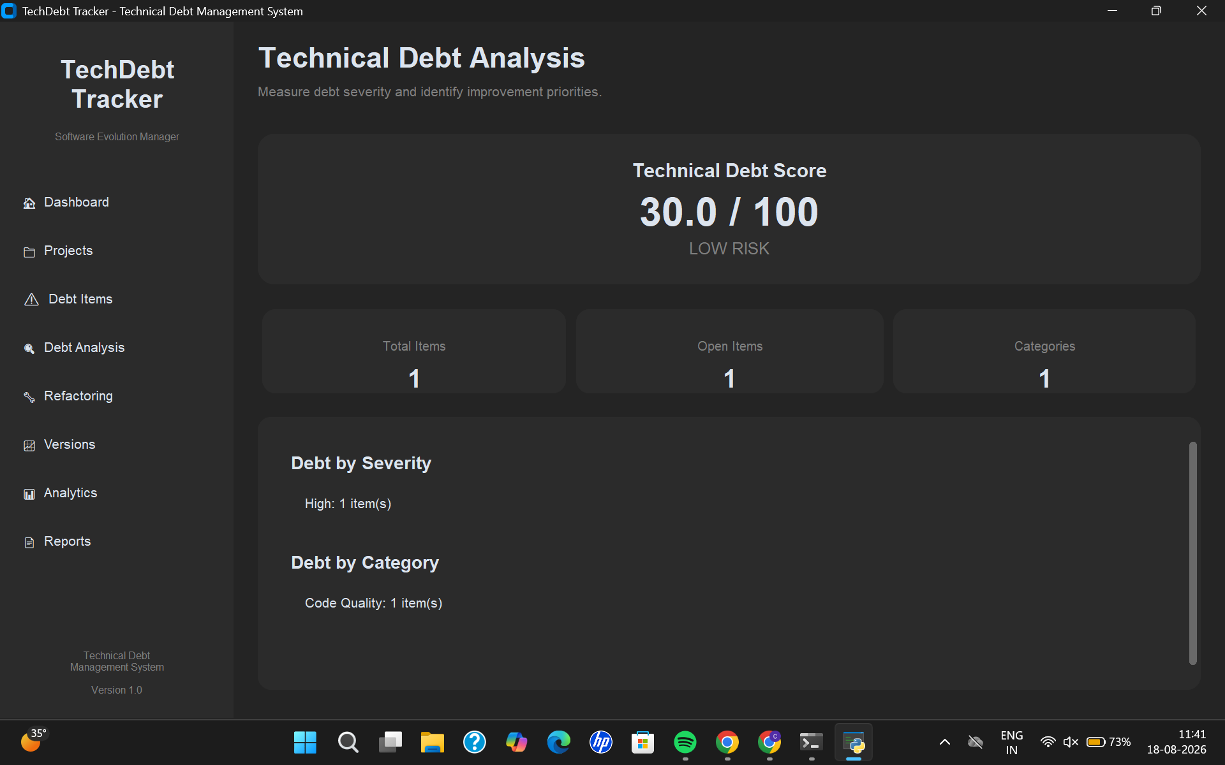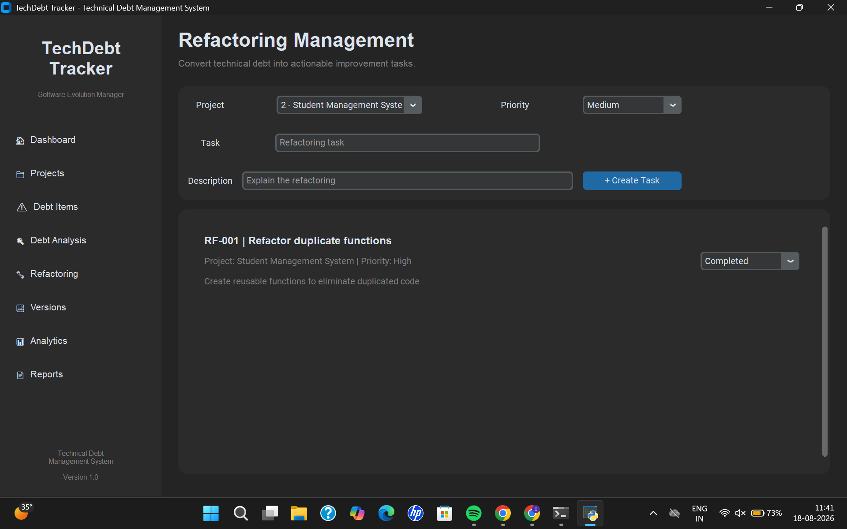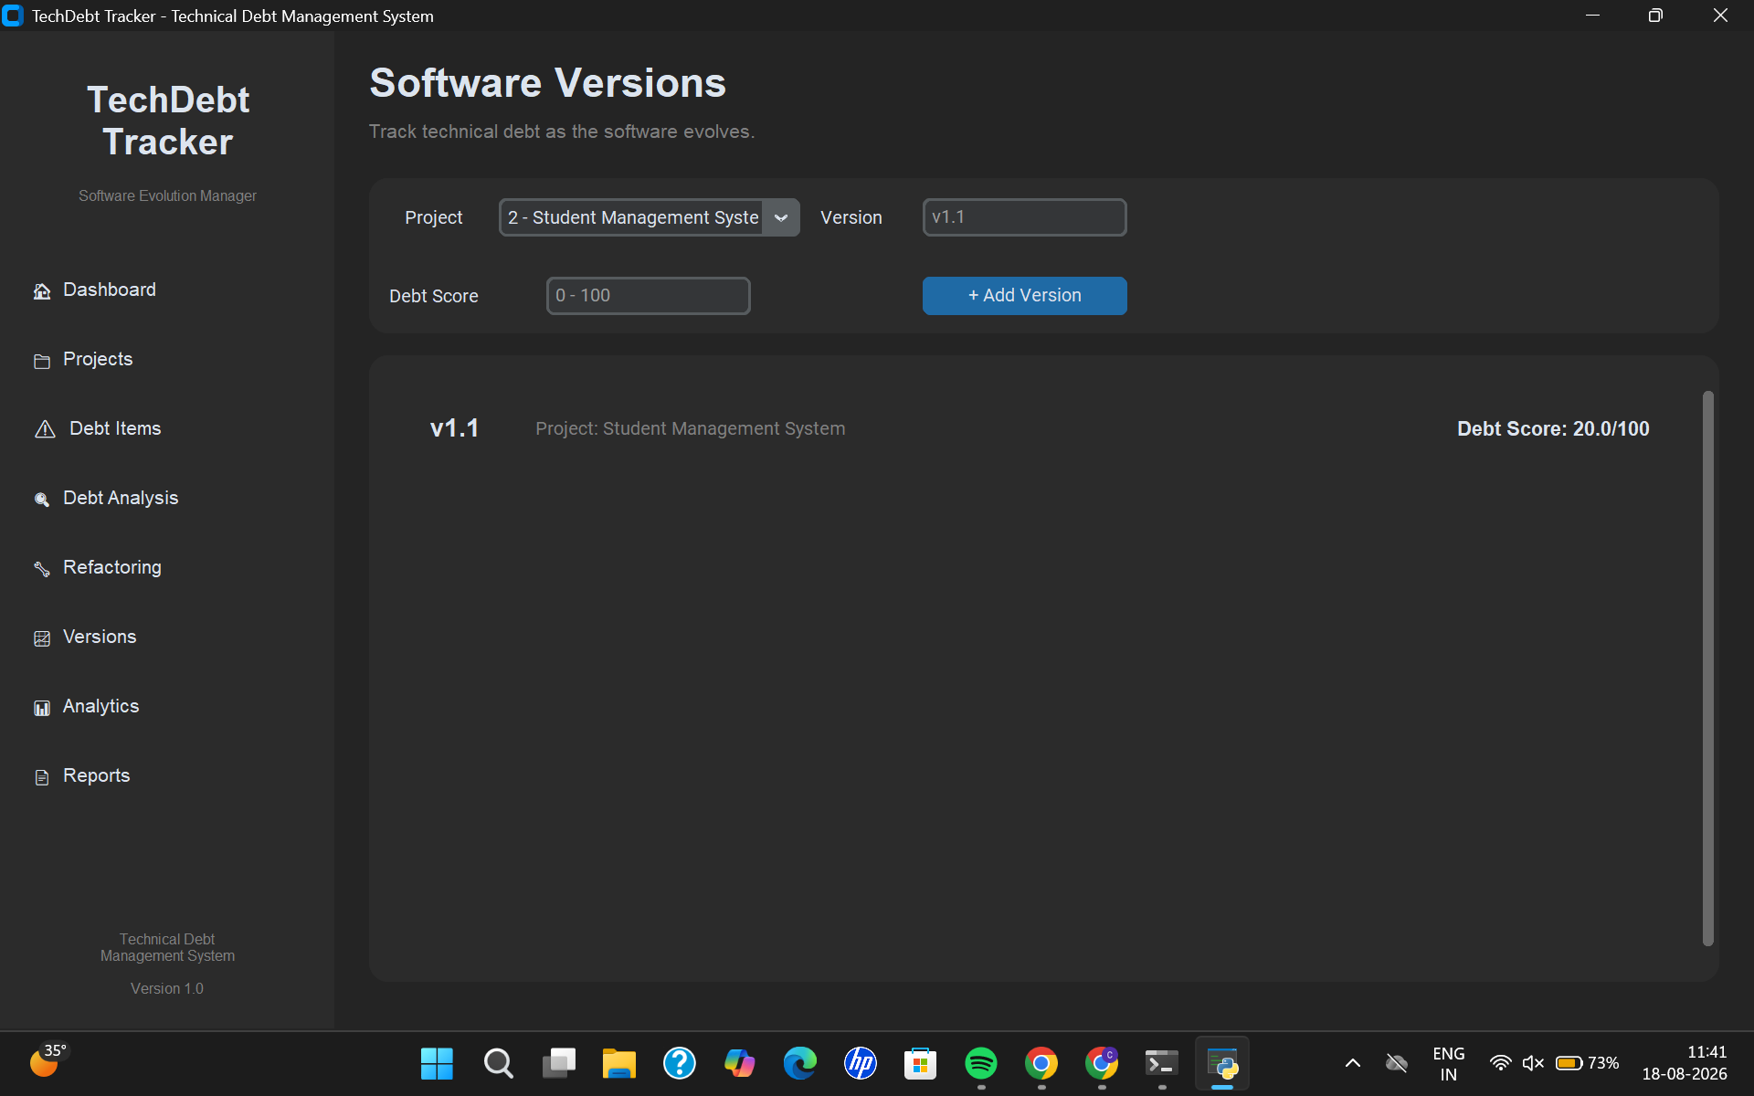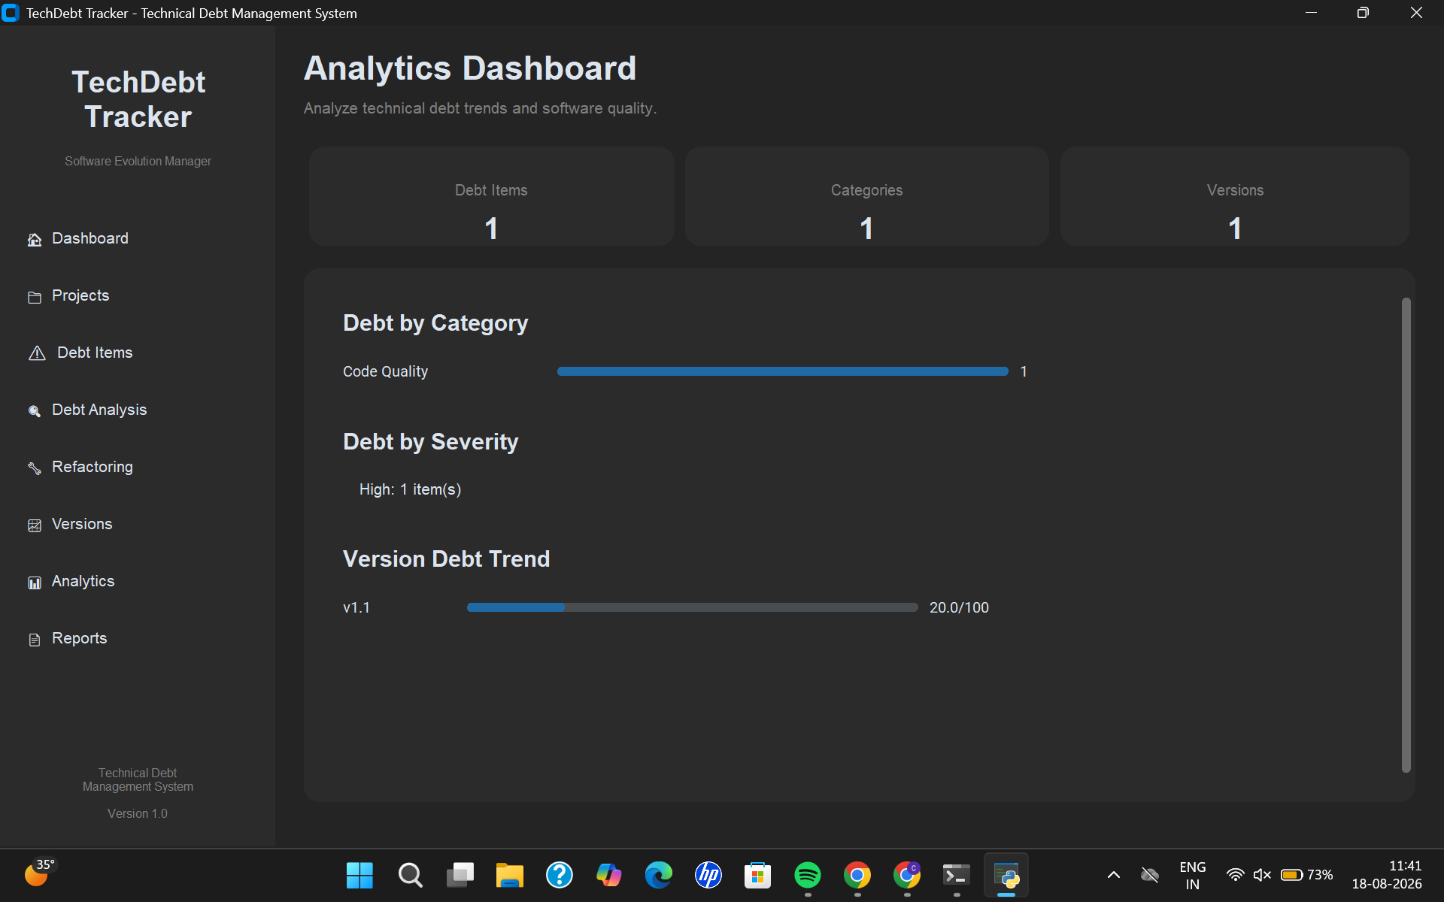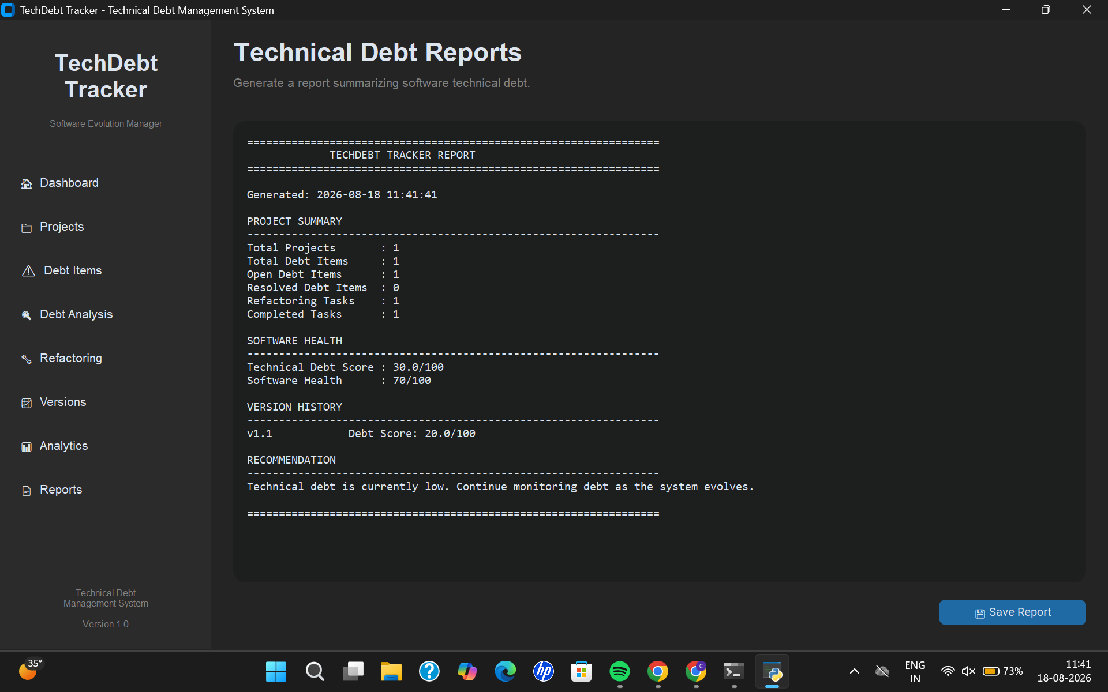

Sequence for working in software:
START
│
▼
Run main.py
│
▼
Dashboard
│
▼
Create Project
│
▼
Add Debt Item
│
▼
Analyze Debt
│
▼
Create Refactoring Task
│
▼
Complete Task
│
▼
Create v1.1
│
▼
Analytics
│
▼
Generate Report
│
▼
SUCCESS

